MXP Addressing

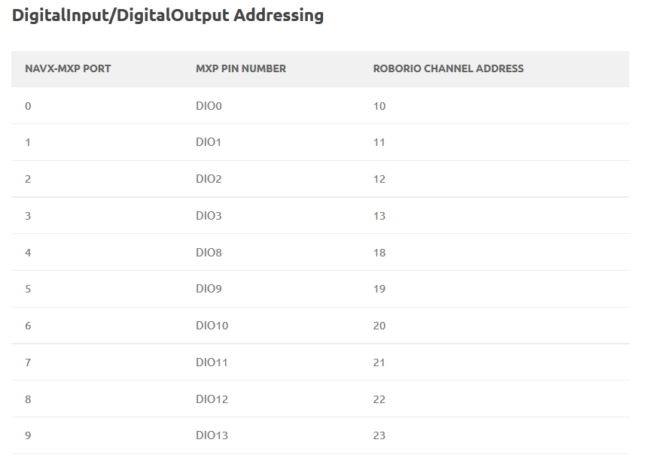

NOTE: The MXP connector has 2 Digital I/O pins which are dedicated to the I2C interface. MXP Digital I/O Pin DIO14 is used for I2C SCL and DIO15 is used for I2C SDA. Since the navX MXP I2C interface is always active, these pins must not be used for any other purpose.

